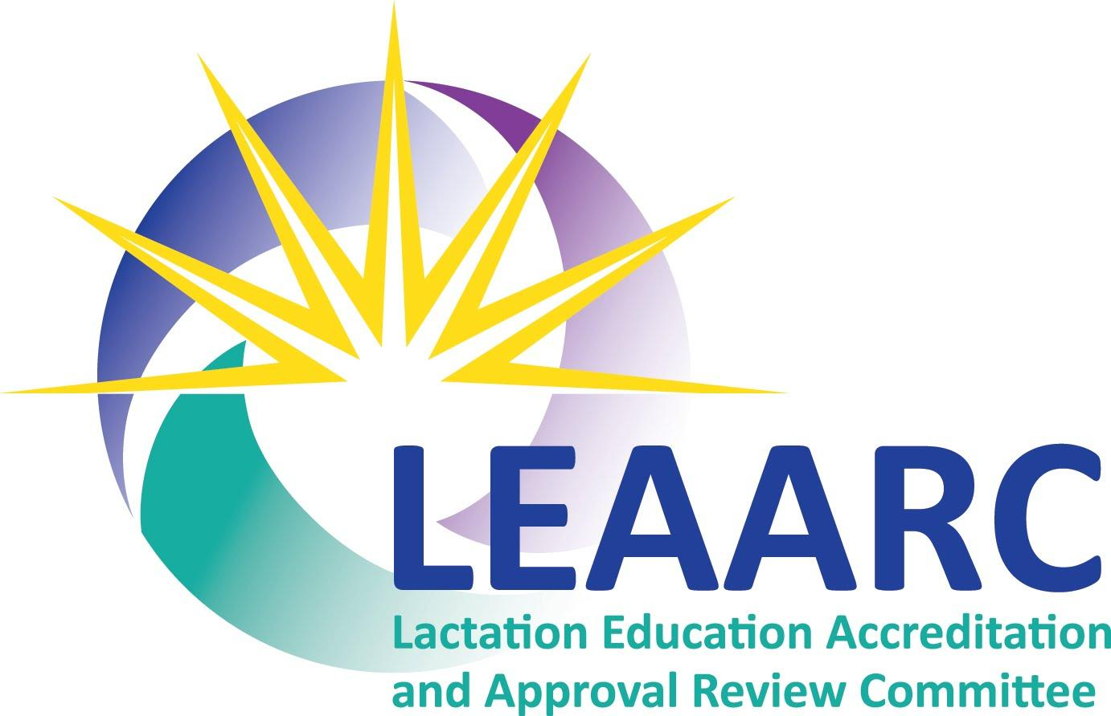
355 Hartford Avenue West
Uxbridge, MA 01569
USA
info@leaarc.org
www.leaarc.org

SITE VISIT REQUEST FORM
LEAARC offers both face-to-face and virtual site visits to programs seeking continuing accreditation. You are not obligated to participate in a virtual site visit.

Programs seeking initial accreditation are required to participate in a face-to-face site visit.

Programs seeking continuing accreditation: Please be advised that LEAARC will let you know whether you are eligible to request a virtual site visit.

I am requesting a: virtual site visit face-to-face site visit.

Please fill in the information below and return it to the LEAARC Executive Office.

Sponsor Name:
Address:
Street Address:
City: State: Zip:

Program Director:
Name:
Email:
Phone: (Office) (Cell)

While face-to-face site visits are scheduled on Monday or Friday, virtual site visits can be scheduled any day of the week. Please identify dates that are between four and six months after the self-study is submitted. Students, faculty, and staff must be available to participate in both virtual and face-to-face site visits.

The self-study has been submitted or will be submitted on or about (mm/dd/yyyy):

Virtual site visit dates: Face-to-Face site visit dates:

1st choice: 1st choice:
2nd choice: 2nd choice:
3rd choice: 3rd choice:

Interviews with students, adjunct faculty, clinical preceptors, and the program Advisory Committee will be scheduled virtually before the date of the site visit. The team leader and LEAARC office will work with the program director to identify these dates.

TRAVEL INFORMATION

Convenient airport(s):
Approximate distance from Program: miles miles

Please recommend a suitable hotel. It should be economical, but clean and safe. There should be a restaurant either in the hotel or within walking distance, if possible.

Hotel #1: Distance from the college:
Address:
City: State:
Phone number:
Restaurant on site: Yes No
Does the college have a favorable corporate rate: Yes No
If YES, does the college need to make the reservation in order to obtain the corporate rate?
Yes No

Hotel #2: Distance from the college:
Address:
City: State:
Phone number:
Restaurant on site: Yes No
Does the college have a favorable corporate rate: Yes No
If YES, does the college need to make the reservation in order to obtain the corporate rate?
Yes No

Hotel #3: Distance from the college:
Address:
City: State:
Phone number:
Restaurant on site: Yes No
Does the college have a favorable corporate rate: Yes No
If YES, does the college need to make the reservation in order to obtain the corporate rate?
Yes No

Please do not hesitate to contact the Executive Office if you have any questions.

